

American International University-Bangladesh (AIUB)

**Department of Computer Science**

**Faculty of Science & Technology (FST)**

**Public Transport Optimization**

A Software Engineering Project Submitted

By

|  |  |  |  |  |
| --- | --- | --- | --- | --- |
| **Semester: Fall (24 – 25)** | | **Section: F** | **Group Number: 5** | |
| SN | Student Name | Student ID | Contribution (CO3+CO4) | Individual Marks |
| 01 | SAZID – AL – ABEDIN | 22-45999-1 | 20% |  |
| 02 | MD. SAIDUZZAMAN SOHAG | 22-46006-1 | 20% |  |
| 03 | MD. SADMAN HOSSAIN | 22-46061-1 | 20% |  |
| 04 | NOUROZE TARANNUM ANANNYA | 22-46062-1 | 20% |  |
| 05 | SEEMANTA TORAFDAR | 21-45968-3 | 20% |  |

The project will be Evaluated for the following Course Outcomes

|  |  |  |
| --- | --- | --- |
| **CO3:** *Select* appropriate software engineering models, project management roles and their associated skills for the complex software engineering project and evaluate the sustainability of developed software, taking into consideration the societal and environmental aspects | Total Marks | |
|  | |
| Appropriate Process Model Selection and Argumentation with Evidence | [5 Marks] |  |
| Evidence of Argumentation regarding process model selection | [5Marks] |  |
| Analysis the impact of societal, health, safety, legal and cultural issues | [5Marks] |  |
| Submission, Defense, Completeness, Spelling, grammar and Organization  of the Project report | [5Marks] |  |
| **CO4:** *Develop* project management plan to manage software engineering projects following the principles of engineering management and economic decision process | Total Marks | |
|  | |
| Develop the project plan, its components of the proposed software products | [5Marks] |  |
| Identify all the activities/tasks related to project management and categorize them within the WBS structure. Perform detailed effort estimation correspond with the WBS and schedule the activities with resources | [5Marks] |  |
| Identify all the potential risks in your project and prioritize them to overcome these risk factors. | [5Marks] |  |

Description of Student’s Contribution in the Project work

|  |
| --- |
| Student Name: SAZID – AL – ABEDIN  Student ID: 22-45999-1  Contribution in Percentage (%): 20%  Contribution in the Project:  ▪ Project Proposal  ▪ System Functional Requirements  ▪ Class Diagram  ▪ Process Model and Role Identification and Responsibilities  ▪ UI/UX Design  ▪ Test plan  ▪ Work bench Structure  ▪ Project Estimation  ▪ Timeline Chart  ▪ Earned Value Analysis  ▪ Risk Table  ▪ Risk Reduction Techniques      _______Sazid_________  Signature of the Student |
| Student Name: MD. SAIDUZZAMAN SOHAG  Student ID: 22-46006-1  Contribution in Percentage (%): 20%  Contribution in the Project:  ▪ Project Proposal  ▪ System Functional Requirements  ▪ Use Case Diagram  ▪ Process Model and Role Identification and Responsibilities  ▪ UI/UX Design  ▪ Test plan and  ▪ Work bench Structure  ▪ Project Estimation  ▪ Timeline Chart  ▪ Earned Value Analysis  ▪ Risk Table  ▪ Risk Reduction Techniques      _______Sohag________  Signature of the Student |
| Student Name: MD. SADMAN HOSSAIN  Student ID: 22-46061-1  Contribution in Percentage (%): 20%  Contribution in the Project:  ▪ Project Proposal  ▪ System Functional Requirements  ▪ Activity Diagram  ▪ Process Model and Role Identification and Responsibilities  ▪ UI/UX Design  ▪ Work bench Structure  ▪ Project Estimation  ▪ Timeline Chart  ▪ Earned Value Analysis  ▪ Risk Table  ▪ Risk Reduction Techniques      _______Sadman________  Signature of the Student |
| Student Name: NOUROZE TARANNUM ANANNYA  Student ID: 22-46062-1  Contribution in Percentage (%): 20%  Contribution in the Project:  ▪ Project Proposal  ▪ System Functional Requirements  ▪ Sequence Diagram  ▪ Process Model and Role Identification and Responsibilities  ▪ UI/UX Design  ▪ Test plan  ▪ Work bench Structure  ▪ Project Estimation  ▪ Timeline Chart  ▪ Earned Value Analysis  ▪ Risk Table  ▪ Risk Reduction Techniques    _______Nouroze____________  Signature of the Student |
| Student Name: SEEMANTA TORAFDAR  Student ID: 21-45968-3  Contribution in Percentage (%): 20%  Contribution in the Project:  ▪ Project Proposal  ▪ System Functional Requirements  ▪ Class Diagram  ▪ Process Model and Role Identification and Responsibilities  ▪ UI/UX Design  ▪ Test plan  ▪ Work bench Structure  ▪ Project Estimation  ▪ Timeline Chart  ▪ Earned Value Analysis  ▪ Risk Table  ▪ Risk Reduction Techniques    _______Seemanto____________  Signature of the Student |

1. **PROJECT PROPOSAL**

* 1. **Background to the Problem**

To address the challenges faced by public transport systems in densely populated cities in Bangladesh, this project aims to develop a digital platform to enhance the accessibility, convenience and efficiency of public transport. Currently, passengers encounter significant difficulties due to a lack of real-time information, poor route management, and inefficient ticketing processes. These issues result in overcrowded buses and trains, long wait times, and reduced reliability, which discourages the use of public transport and increases reliance on private vehicles.

The root cause of this problem lies in the absence of real-time data and streamlined ticketing solutions, leading to passenger frustration and overall system inefficiency. Addressing these issues is essential for creating a more sustainable urban transport system that meets the demands of a growing population while promoting public transport usage. By providing real-time tracking, route planning, ticketing, and availability updates, this app seeks to make public transportation a more reliable, accessible and attractive option for daily passengers, contributing to better urban mobility and environmental sustainability.

* 1. **Solution to the Problem**

The primary objective of this project is to develop a mobile application that enhances the public transportation experience by addressing common issues faced by passengers in urban areas. This app will integrate route searches, live tracking, suggestions, and a secure QR-code ticketing system to offer a convenient, reliable alternative to current transportation options. This solution aims to solve problems related to the lack of real-time information, overcrowding, and inefficient ticketing, making public transport a more attractive choice.

The proposed solution involves a GPS-integrated public transport app with features like route planning, real-time tracking, and cashless secure ticketing. The solution is feasible and scalable to meet business objectives since it supports widely-used mobile and GPS technology, requiring minimal additional infrastructure investment while increasing passenger satisfaction and potentially boosting public transport usage.

**Key Functionalities of the Proposed Solution:**

* + - **Route Search**: Provides an intuitive “From - To” search feature that recommends bus routes and options.
    - **Bus Suggestion**: It will show available buses on that selected route.
    - **Bus Information**: Tapping on a bus option provides details, including Estimated Time Arrival (ETA) and occupancy status, using GPS data.
    - **Map with Route Suggestions**: A visual interface that offers route suggestions and relevant information.
    - **Ticket Purchase and Validation**: Secure in-app ticketing system with one-hour pre-scan validity, reducing cash transactions.
    - **Live Tracking**: Real-time bus tracking, updating users with accurate ETAs and traffic conditions.

**Target User Groups**: The primary users include daily commuters, students, and professionals in urban areas who depend on public transport. Secondary users are transport operators and government agencies that oversee public transit systems. Commuters benefit through:

* + - Live tracking will reduced wait times.
    - Access to real-time updates that enhance efficiency.
    - Cashless transactions that streamline the ticketing process.

**Comparison and Extensions in the Proposed Study:**

Building on existing solutions, our study addresses key gaps in urban public transport management to better serve densely populated areas like Bangladesh.

* + 1. **User-Centric Mobile Application**: Unlike previous web-based approaches, such as the low-cost GPS model for mobile tracking presented in [1] and [2], our app focuses on a mobile platform for both users and drivers, centralizing route suggestions, live tracking, and digital ticketing.
    2. **Integrated Ticketing**: While the reviewed studies focus on bus tracking, our solution extends functionality by integrating QR-based cashless ticketing, enhancing convenience and security for commuters.
    3. **Advanced Route Planning**: Beyond real-time tracking, our app includes route planning with estimated arrival times and occupancy data, helping users reduce wait times and overcrowding.
    4. **Enhanced Sustainability**: Our project encourages public transport usage by improving convenience, supporting goals like reduced congestion and emissions, aligning with urban sustainability efforts.

**References:**

1. "Cost-Effective Bus Tracking Using Driver GPS," *IEEE Xplore*, [Online]. Available: [https://ieeexplore.ieee.org/document/10544750.](https://ieeexplore.ieee.org/document/10544750)
2. "Smart City Bus Tracking for Improved Urban Mobility," *IEEE Xplore*, [Online]. Available: [https://ieeexplore.ieee.org/document/10346218.](https://ieeexplore.ieee.org/document/10346218)

**Existing studies in the problem area and solution:** Various software platforms, such as Uber and Pathao, offer real-time location tracking and navigation but focus on ridesharing on the other hand public transportation doesn’t provide this. Studies on smart cities and transportation highlight that good public transport apps should include real-time data, tools to predict arrival times, and an easy-to-use interface. These studies highlight the importance of digital integration, which our project addresses by combining tracking, routing, and ticketing.

**2. SOFTWARE DEVELOPMENT LIFE CYCLE**

**2.1 Process Model:**

The **Incremental model** is particularly well-suited for a **Public Transport Optimization System** due to its flexibility, adaptability, and ability to handle dynamic requirements. Public transport systems are subject to constant changes in traffic patterns, regulations, and user needs, which makes the Incremental model ideal. It allows development in small, manageable chunks, meaning that core functionalities like **route optimization**, **scheduling**, and **tracking** can be delivered early and continuously refined based on real-time feedback from users and stakeholders. This early delivery ensures that even if the system isn’t fully complete, users can still benefit from the improvements made in each increment.

**Comparison Between other process model**:

**Waterfall**: Less suited due to its rigid structure and the need for all requirements to be defined upfront, making it difficult to adapt to the dynamic nature of public transport.

**RAD (Rapid Application Development)**: While RAD emphasizes fast prototyping and rapid iterations, it may struggle with scaling complex systems and managing integration across large, real-time datasets like those in public transport optimization. It also requires significant upfront investment in prototyping.

**DSDM (Dynamic Systems Development Method)**: DSDM is more flexible than Waterfall, but it still has predefined phases and a focus on upfront planning, which can limit adaptability compared to the Incremental model.

**XP (Extreme Programming)**: XP emphasizes best practices for software engineering, which is valuable for system quality but may not provide the same level of structured release planning and stakeholder management as the Incremental model. It’s also highly focused on programming practices and not as suitable for large-scale, multi-phase project management like public transport systems.

**Scrum**: While Scrum promotes iterative development and flexibility, it is more focused on software development teams and short iterations (sprints) than on large-scale system integration. Public transport optimization typically requires a more phased approach with clear, scheduled milestones, which the Incremental model handles better.

**2.2 Project Role Identification and Responsibilities**

The development and management of the public transport optimization system require clearly defined roles and responsibilities. These roles ensure effective coordination among stakeholders and the development team, focusing on iterative progress and responsiveness to feedback.

1. **Project Manager**
   * Ensures the successful execution of the project using the Incremental Model.
   * Oversees the delivery of critical functionalities in each increment, ensuring alignment with stakeholder goals.
   * Monitors risks and resource allocation for smooth project execution.
2. **Product Owner**
   * Represents the interests of transport authorities, users, and other stakeholders.
   * Manages the feature backlog, prioritizing functionalities like route optimization, live tracking, and payment processing.
   * Collects feedback after each increment to refine upcoming deliverables.
3. **Development Team**
   * Designs and implements the system in increments, focusing on features such as ticket generation, user management, and live tracking.
   * Conducts integration testing at each stage to ensure seamless operation of newly added modules.
   * Develops user interfaces and backend systems for dynamic data handling.
4. **Testers**
   * Execute functional, integration, and regression testing for each increment.
   * Ensure real-time functionalities like bus tracking and notifications meet performance standards.
   * Validate security measures for payment processing and user data.
5. **Authority**
   * Provide requirements and feedback for each delivered increment.
   * Collaborate with the Product Owner to define priorities and validate completed features.
6. **SOFTWARE REQUIREMENTS ANALYSIS**

**Functional Requirements**

**Role: User**

1. **User Login**
   1. The software will allow users to log in with their registered email and password.

**1.2** The login credentials (email and password) will be verified against the database records.  
**1.3** Upon successful login, the user will be directed to their personalized home page.  
**1.4** If the login fails, the user will receive an error message indicating incorrect credentials.  
**1.5** If the number of login attempts exceeds three, the system shall temporarily lock the account for one hour (optional function).

**Priority Level**: High  
 **Precondition**: User has a valid email and password.

1. **User Registration**

**2.1** The system shall allow new users to create an account by providing necessary information (name, email, password).  
**2.2** The email address must be unique and verified through a confirmation link sent to the user's email.

**Priority Level**: High  
**Precondition**: None.

1. **Route Search**

**3.1** The app shall provide a "From - To" search feature to recommend bus routes based on user input.  
**3.2** The system shall display available bus routes, including stops and transfers.  
**3.3** Users shall be able to filter routes based on travel time, number of transfers, and bus capacity.

**Priority Level**: High  
**Precondition**: User is logged in.

1. **Live Bus Tracking**

**4.1** The app will allow users to view real-time bus locations on a map using GPS data.  
**4.2** Users shall receive estimated arrival times (ETAs) for buses at their selected stops.  
**4.3** The system shall automatically update ETAs based on current traffic conditions.

**Priority Level**: High  
**Precondition**: User has searched for a route.

1. **Bus Information**

**5.1** The system shall provide detailed information about each bus, capacity, and occupancy status.  
**5.2** Users shall be able to tap on a bus to see additional details, including the estimated time of arrival (ETA) and current location.

**Priority Level**: Medium  
**Precondition**: User has accessed bus route information.

1. **Ticket Purchase**

**6.1** The app shall allow users to purchase tickets securely within the application.  
**6.2** Users shall have the option to pay via various digital payment methods (credit/debit cards, mobile wallets).  
**6.3** The system shall provide a QR code for ticket validation at the bus stop.

**Priority Level**: High  
**Precondition**: User is logged in and has selected a route.

1. **Save Payment Option:**

**7.1** The app will save the Payment information of the user if they allow to save the info to make the payment smoother.

**7.2** It will be an one tap payment. (MFS info will be saved).

**Priority Level:** Medium

**Precondition**: user have to make at least one payment using any payment option.

1. **Live Notifications**

**8.1** The app shall send push notifications to users about their selected bus's real-time status (delays, arrivals).  
**8.2** Users shall have the option to enable or disable notifications in their settings.

**Priority Level**: Medium  
**Precondition**: User has opted in for notifications.

1. **User Profile Management**

**9.1** Users shall be able to view and edit their personal information (name, email, password, age, phone number)  
**9.2** The system shall allow users to view their purchase history and current tickets.

**Priority Level**: Medium  
**Precondition**: User is logged in.

1. **Show Ticket Info:**

**10.1** After purchasing a ticket , details of that ticket will be showed and will be mailed to the user.

**10.2** User can download the PDF version of the ticket.

**Priority Level**: High  
**Precondition**: User have purchased a ticket.

**11**. **User Rating System for Buses**

**11.1** The app shall allow users to rate their bus experience after each journey (e.g., cleanliness, punctuality, driver behavior).  
**11.2** The system shall aggregate ratings to help operators identify areas for improvement.

**Priority Level**: Low  
**Precondition**: User has completed a trip.

1. **Accessibility Features**

**12.1** The app shall include features for users with disabilities, such as voice commands and visual aids.  
**12.2** Information about wheelchair-accessible buses and routes shall be clearly displayed.

**Priority Level**: High  
**Precondition**: None.

1. **Multi-Language Support**

**13.1** The app shall provide multi-language support to accommodate users from different linguistic backgrounds.  
**13.2** Users shall be able to select their preferred language during registration and in settings.

**Priority Level**: Medium  
**Precondition**: None.

**Role: Bus Authority**

**1. Bus Owner Registration and Validation**

**1.1** The system shall allow bus owners to register by entering their National ID (NID) and other necessary details.

**1.2** The system shall validate the bus owner’s details through the BRTC (Bangladesh Road Transport Corporation) and NID database to ensure legitimate registration.

**Priority Level**: High  
**Precondition**: None.

**2. Bus Owner Profile Management**

**2.1** The bus owner shall be able to view and manage the details of their buses, including bus numbers, routes, and schedules.

**2.2** The system shall allow the bus owner to update their personal and business information (name, business details, contact information).

**Priority Level**: Mediam  
**Precondition**: Bus owner is registered and logged in.

**3. Employee Management**

**3.1** The bus owner shall be able to add employees (drivers, conductors) to their company account by providing the employee's details and assigning a password.

**3.2** The system shall allow the bus owner to update or delete employee accounts.

**3.3** The system shall allow the bus owner to change the passwords of employees, with the restriction that only the owner can change employee passwords.

**Priority Level**: High  
**Precondition**: Bus owner is logged in.

**4. Employee Ticket Verification and Bus Information**

**4.1** Employees (drivers, conductors) shall be able to log in with a unique password provided by the bus owner.

**4.2** Employees shall have the option to scan passenger tickets (QR code-based) and verify the ticket for validity.

**4.3** Employees shall have access to view route details, including the current bus location and ETA, as well as the list of passengers on the bus.

**4.4** The system shall allow employees to view detailed information about passengers, such as name, contact info, and ticket validity.

**Priority Level**: High  
**Precondition**: Employee is logged in.

**5. Passenger Check-in and Check-out Verification**

**5.1** The system require employees to scan a passenger’s ticket when they get on the bus to validate the passenger’s entry.

**5.2** The system require employees to scan a passenger’s ticket again when they get off to confirm that they have completed their journey.

**5.3** If a passenger fails to check out, the system shall apply an additional charge for the unverified journey.

**Priority Level**: High  
**Precondition**: Employee has scanned the ticket when a passenger get in.

**6. Real-Time Bus Vacancy and Seat Availability**

**6.1** The system shall allow the bus owner and employees to view real-time bus occupancy and available seats.

**6.2** When a passenger checks in and out, the system shall update the seat availability in real time for both the client and the bus owner apps.

**6.3** The system shall notify the bus owner and employees when the bus reaches full capacity.

**Priority Level**: High  
**Precondition**: Bus is operating and has passengers.

**7. Bus Owner Financial Overview and Reporting**

**7.1** The bus owner shall be able to view financial reports, including daily earnings, ticket sales, and outstanding charges due to unverified check-outs.

**7.2** The system shall allow the bus owner to generate and export financial reports for further analysis.

**Priority Level**: Medium  
**Precondition**: Bus owner is logged in.

**4. SYSTEM DESIGN SPECIFICATION**

**4.1 Class Diagram:**

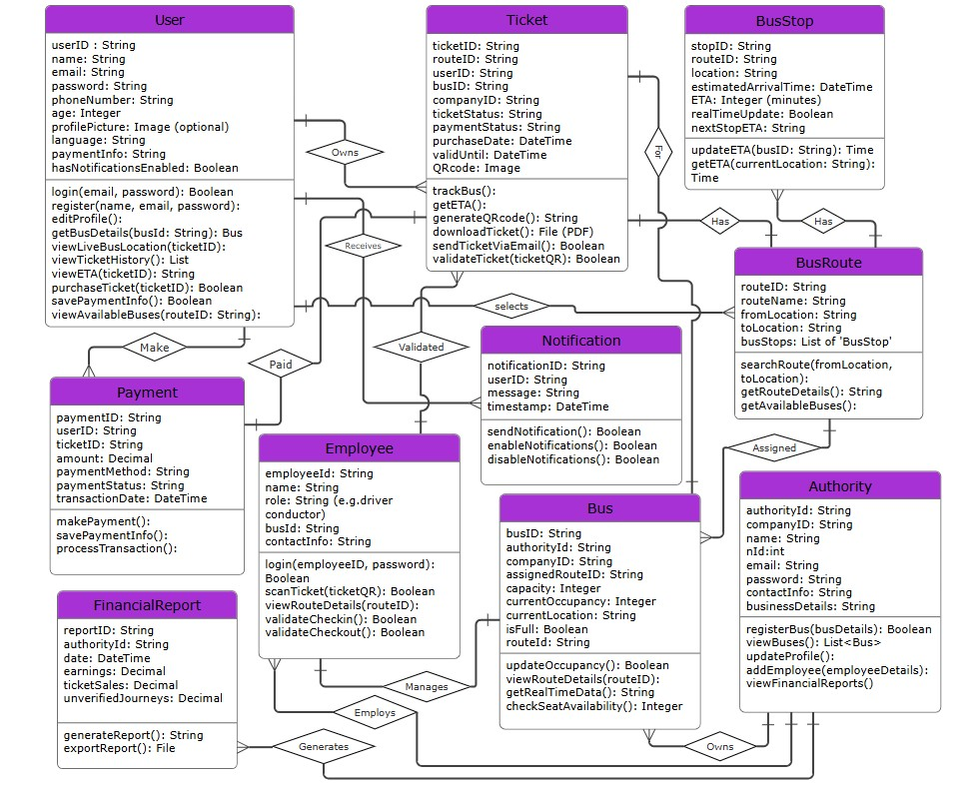

**4.2 Use-case Diagram:**

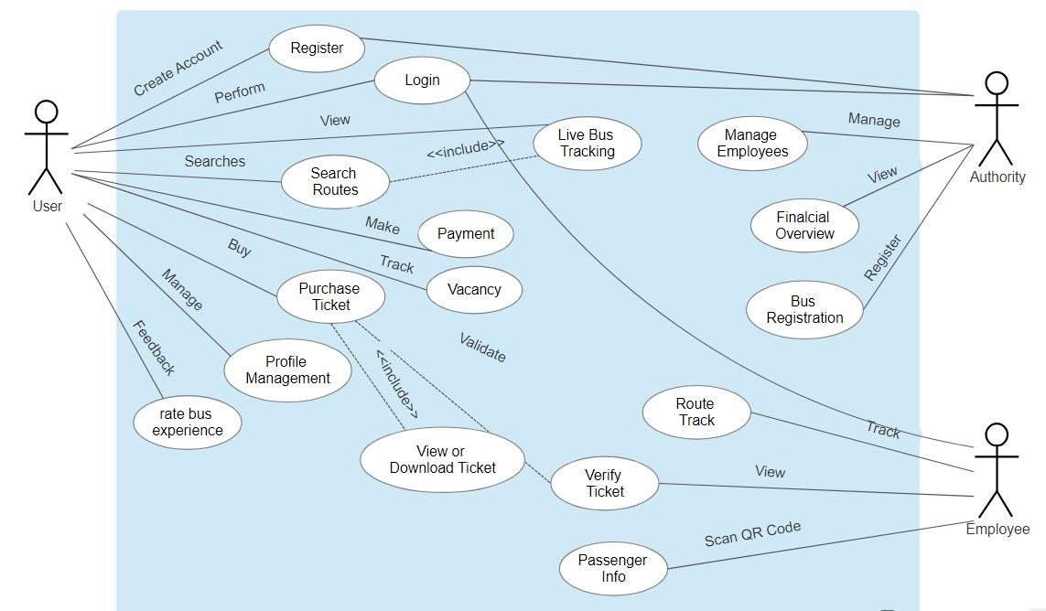

**4.3 Sequence Diagram:**

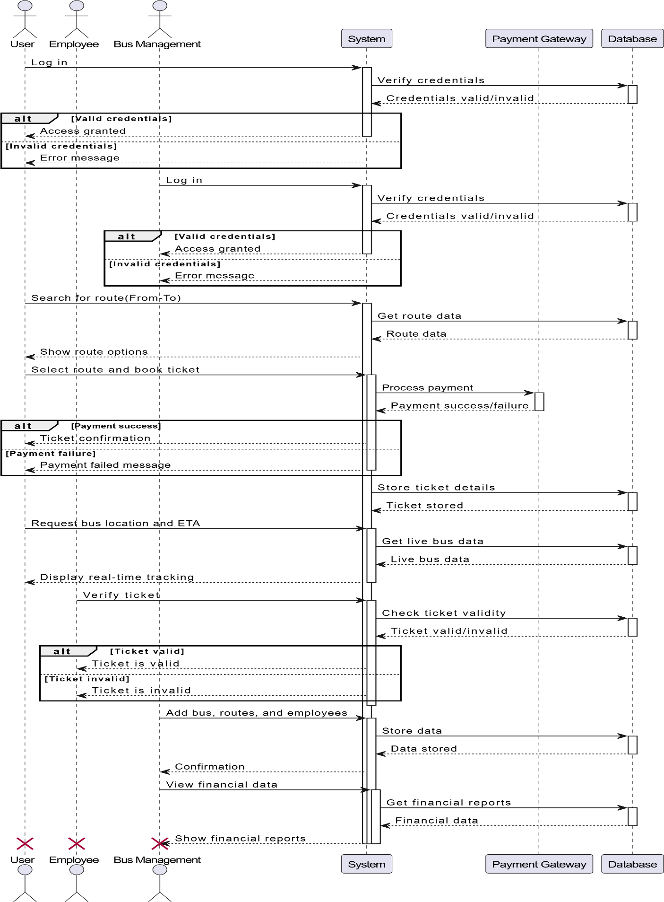

**4.4 Activity Diagram**

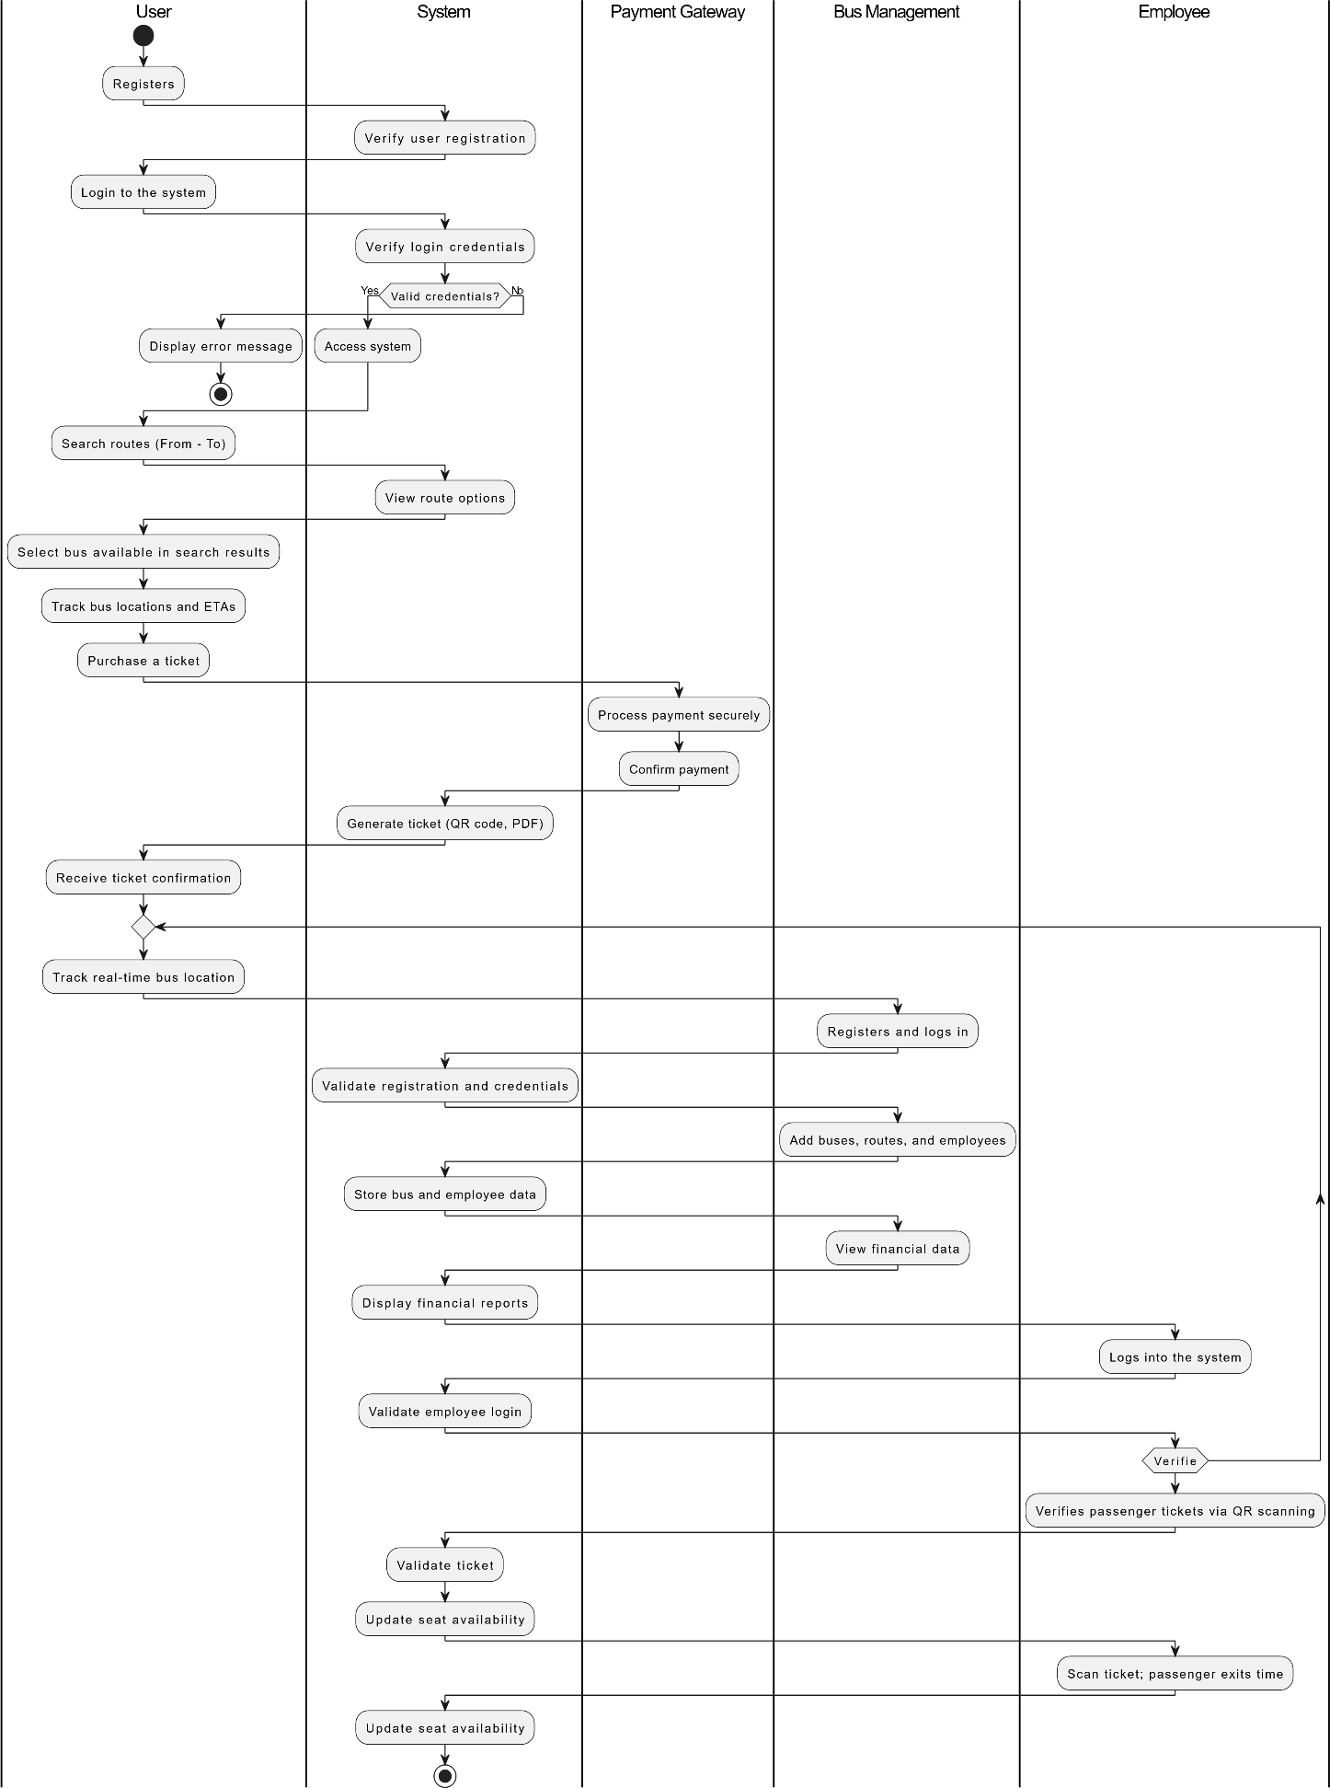

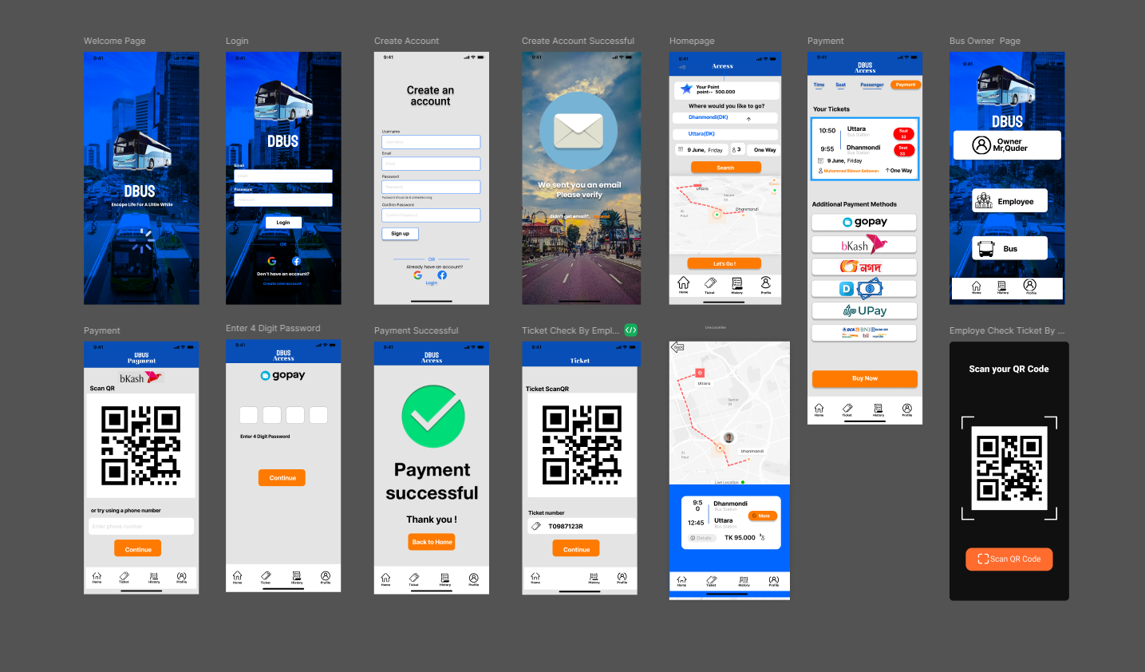**UI / UX Design (Prototype)**

**UI / UX Design (Prototype)**

|  |  |  |  |  |
| --- | --- | --- | --- | --- |
| Project Name: Public Transportation Optimization | | | Test Designed By: Sazid-Al-Abedin | |
| Test Case ID: FR_U1 | | | Test Designed Date: 17/12/2024 | |
| Test Priority (Low, Medium, High): High | | | Test Executed By: | |
| Module Name: User Login | | | Test Execution Date: | |
| Test Title: Verify login with valid username and password | | | | |
| Description: Test user login functionality with valid credentials | | | | |
| Precondition (if any): User has valid email and password | | | | |
| Test Steps | Test Data | Expected Results | Actual Results | Status  (Pass / Fail) |
| 1. Go to the login page | Username: user@gmail.com | Login page should load successfully |  |  |
| 1. Enter valid email and password | Password: User@123 | User should be allowed to submit the form |
| 1. Click the login button |  | User should be logged in |
| 1. Validate redirection after login |  | User is redirected to the home page |
| Post Condition: User is logged in successfully, and session details are created. | | | | |

|  |  |  |  |  |
| --- | --- | --- | --- | --- |
| Project Name: Public Transportation Optimization | | | Test Designed By: Sazid-Al-Abedin | |
| Test Case ID: FR_U2 | | | Test Designed Date: 17/12/2024 | |
| Test Priority (Low, Medium, High): High | | | Test Executed By: | |
| Module Name: User Registration | | | Test Execution Date: | |
| Test Title: Verify user registration with valid input data | | | | |
| Description: Test new user registration functionality in the application | | | | |
| Precondition (if any): None | | | | |
| Test Steps | Test Data | Expected Results | Actual Results | Status  (Pass / Fail) |
| 1. Go to the registration page |  | Registration page should load successfully |  |  |
| 1. Enter valid registration information | Name: Wyan Bruce Email: [bruce@gmail.com](mailto:bruce@gmail.com)  Password: Bruce@1 | System accepts user input |
| 1. Click submit |  | Confirmation email is sent to user |
| 1. Verify the confirmation email | Email: Confirmation link | Account is successfully verified |
| 1. Attempt to log in with new credentials | Username:  [bruce@gmail.com](mailto:bruce@gmail.com)  Password: Bruce@1 | User should successfully log in |
| Post Condition: User account is created, verified, and functional for login. | | | | |

|  |  |  |  |  |
| --- | --- | --- | --- | --- |
| Project Name: Public Transport Optimization | | | Test Designed By:  Md. Sadman Hossain | |
| Test Case ID: FR_U3 | | | Test Designed Date: 1/21/2025 | |
| Test Priority (Low, Medium, High): High | | | Test Executed By: | |
| Module Name: Route Search | | | Test Execution Date: | |
| Test Title: Verify bus route search functionality | | | | |
| Description: Test the "From-To" route search feature | | | | |
| Precondition (if any): User is logged in | | | | |
| Test Steps | Test Data | Expected Results | Actual Results | Status  (Pass / Fail) |
| 1. Input "From" and "To" locations | From : A  To : B | System displays available routes |  |  |
| 1. Select a route | Route: Option 1 | Selected route details are displayed |
| Post Condition: User can search and view bus routes. | | | | |

|  |  |  |  |  |
| --- | --- | --- | --- | --- |
| Project Name: Public Transport Optimization | | | Test Designed By:  Md. Sadman Hossain | |
| Test Case ID: FR_U4 | | | Test Designed Date: 1/21/2025 | |
| Test Priority (Low, Medium, High): | | | Test Executed By: | |
| Module Name: Live Bus Tracking | | | Test Execution Date: | |
| Test Title: Verify real-time bus tracking functionality | | | | |
| Description: Test the ability to track buses in real time | | | | |
| Precondition (if any): User has searched for a route | | | | |
| Test Steps | Test Data | Expected Results | Actual Results | Status  (Pass / Fail) |
| 1. Search and select a bus route | Route: A → B | Route details page opens |  |  |
| 1. Enable live tracking |  | Real-time bus locations are shown on a map |
| 1. Check Estimated Time Arrival (ETA) updates |  | ETA update dynamically |
| Post Condition: Real-time location and ETA are displayed for the selected route | | | | |

|  |  |  |  |  |
| --- | --- | --- | --- | --- |
| Project Name: Public Transport Optimization | | | Test Designed By: Md. Saiduzzaman Sohag | |
| Test Case ID: FR_U5 | | | Test Designed Date: 1/21/2025 | |
| Test Priority (Low, Medium, High): Medium | | | Test Executed By: | |
| Module Name: Bus Information | | | Test Execution Date: | |
| Test Title: Verify detailed bus information display | | | | |
| Description: Test that users can view detailed bus information | | | | |
| Precondition (if any): User has accessed route information | | | | |
| Test Steps | Test Data | Expected Results | Actual Results | Status  (Pass / Fail) |
| 1. Search for a route | Route: A → B | Route details are displayed |  |  |
| 1. Tap on a bus | Bus: Option 1 | Bus capacity and location details |
| Post Condition: Users can view detailed bus information. | | | | |

|  |  |  |  |  |
| --- | --- | --- | --- | --- |
| Project Name: Public Transport Optimization | | | Test Designed By: Md. Saiduzzaman Sohag | |
| Test Case ID: FR_U6 | | | Test Designed Date: 1/21/2025 | |
| Test Priority (Low, Medium, High): High | | | Test Executed By: | |
| Module Name: Ticket Purchase | | | Test Execution Date: | |
| Test Title: Verify secure ticket purchase functionality | | | | |
| Description: Test that users can securely purchase tickets | | | | |
| Precondition (if any): User is logged in and has selected a route | | | | |
| Test Steps | Test Data | Expected Results | Actual Results | Status  (Pass / Fail) |
| 1. Select a route | Route: A → B | Route details are displayed |  |  |
| 1. Go to the purchase page |  | Payment page loads |
| 1. Select a payment method and pay | Method: MFS(bKash, Rocket etc) | Payment successfully |
| Post Condition: Ticket is purchased, and a QR code is issued. | | | | |

|  |  |  |  |  |
| --- | --- | --- | --- | --- |
| Project Name: | | | Test Designed By:  Nouroze Tarannum Anannya | |
| Test Case ID: FR_U7 | | | Test Designed Date:  1/21/2025 | |
| Test Priority (Low, Medium, High): | | | Test Executed By: | |
| Module Name: Save Payment Option | | | Test Execution Date: | |
| Test Title: Verify the functionality to save payment information | | | | |
| Description: Test that users can save their payment details to enable smoother future payments | | | | |
| Precondition (if any): User has made at least one payment using any payment method | | | | |
| Test Steps | Test Data | Expected Results | Actual Results | Status  (Pass / Fail) |
| 1. Initiate a ticket purchase process | Route: A → B, Payment Method: MFS(bKash,Rocket etc) | Payment page is displayed |  |  |
| 1. Enter payment details and enable "Save" | Phone Number: 01611252799 | Option to save payment details appears |
| 1. Complete payment | Payment Amount: 40tk | Payment is successfully processed |
| 1. Verify payment details saved |  | System confirms payment details saved |
| 1. Complete payment using saved details |  | Payment is processed with one tap |
| Post Condition: User's payment information is saved securely and can be used for future payments with one tap. | | | | |

|  |  |  |  |  |
| --- | --- | --- | --- | --- |
| Project Name: | | | Test Designed By:  Nouroze Tarannum Anannya | |
| Test Case ID: FR_U8 | | | Test Designed Date:  1/21/2025 | |
| Test Priority (Low, Medium, High): | | | Test Executed By: | |
| Module Name: Live Notifications | | | Test Execution Date: | |
| Test Title: Verify live notifications functionality | | | | |
| Description: Test push notifications for real-time bus updates | | | | |
| Precondition (if any): User has enabled notifications | | | | |
| Test Steps | Test Data | Expected Results | Actual Results | Status  (Pass / Fail) |
| 1. Enable notifications in settings |  | Notifications enabled successfully |  |  |
| 1. Track a bus route | Route: A → B | User receives notifications for ETAs |
| Post Condition: Notifications are sent based on real-time updates. | | | | |

|  |  |  |  |  |
| --- | --- | --- | --- | --- |
| Project Name: Public Transport Optimization | | | Test Designed By:  Seemanta Torafdar | |
| Test Case ID: FR_U9 | | | Test Designed Date:  17-12-2024 | |
| Test Priority (Low, Medium, High): Medium | | | Test Executed By: | |
| Module Name: User Profile Management | | | Test Execution Date: | |
| Test Title: Verify user profile management functionality | | | | |
| Description: Test that users can view and edit their personal information and view their purchase history | | | | |
| Precondition (if any): User is logged in | | | | |
| Test Steps | Test Data | Expected Results | Actual Results | Status  (Pass / Fail) |
| 1. Go to the "Profile" page |  | Profile page is displayed |  |  |
| 1. View personal information |  | User details (name, email, phone, etc.) are displayed correctly |
| 1. Edit personal information | Name: John Doe → John D., Phone: 1234567890 | Updated information is saved and reflected |  |  |
| 1. Verify purchase history |  | Verify purchase history |
| 1. Attempt invalid updates | Email: invalid. Email | System displays an error message |
| Post Condition: User's personal information is updated successfully, and purchase history is displayed correctly. | | | | |

|  |  |  |  |  |
| --- | --- | --- | --- | --- |
| Project Name: Public Transport Optimization | | | Test Designed By:  Seemanta Torafdar | |
| Test Case ID: FR_U10 | | | Test Designed Date:  17-12-2024 | |
| Test Priority (Low, Medium, High): High | | | Test Executed By: | |
| Module Name: Show Ticket Info | | | Test Execution Date: | |
| Test Title: Verify ticket details and PDF generation | | | | |
| Description: Test that purchased tickets are displayed and downloadable | | | | |
| Precondition (if any): User has purchased a ticket | | | | |
| Test Steps | Test Data | Expected Results | Actual Results | Status  (Pass / Fail) |
| 1. Go to "My Tickets" section |  | Purchased ticket details are displayed |  |  |
| 1. Download ticket as PDF |  | Ticket PDF is downloaded successfully |
| Post Condition: Ticket details are shown and downloadable. | | | | |

|  |  |  |  |  |
| --- | --- | --- | --- | --- |
| Project Name: Public Transport Optimization | | | Test Designed By:  Sazid-Al-Abedin | |
| Test Case ID: FR_M1 | | | Test Designed Date:  17-12-2024 | |
| Test Priority (Low, Medium, High): High | | | Test Executed By: | |
| Module Name: Bus AuthorityRegistration and Validation | | | Test Execution Date: | |
| Test Title: Verify Bus Authority registration and validation functionality | | | | |
| Description: Ensure the system allows Bus Authority to register and validates their details through BRTC and NID databases. | | | | |
| Precondition (if any): None | | | | |
| Test Steps | Test Data | Expected Results | Actual Results | Status  (Pass / Fail) |
| 1. Go to the bus authority registration page |  | Registration page is displayed |  |  |
| 1. Enter valid National ID (NID) and details | NID: 1234567890, Name: John ,  Contact: 01736365742 | System accepts the details and validates through BRTC/NID database |
| 1. Submit registration |  | Registration is completed successfully |
| 1. Enter invalid NID or incomplete details | NID: invalid | System shows error message: "Invalid NID or incomplete details" |
| Post Condition: The Bus Authority registration details are validated and stored in the system. | | | | |

|  |  |  |  |  |
| --- | --- | --- | --- | --- |
| Project Name: Public Transport Optimization | | | Test Designed By:  Md. Sadman Hossain | |
| Test Case ID: FR_M2 | | | Test Designed Date:  17-12-2024 | |
| Test Priority (Low, Medium, High): High | | | Test Executed By: | |
| Module Name: Employee Management | | | Test Execution Date: | |
| Test Title: Verify the functionality to manage employees | | | | |
| Description: Ensure Bus Authority can add, update, and delete employees. | | | | |
| Precondition (if any): Bus Authority is logged in | | | | |
| Test Steps | Test Data | Expected Results | Actual Results | Status  (Pass / Fail) |
| 1. Go to employee management page |  | Employee management page is displayed |  |  |
| 1. Add a new employee | Name: Jane Doe, Role: Driver, Password: 12345 | Employee is added successfully |
| 1. Update employee details | Name: Jane Doe → Jane D. | Details updated successfully |
| 1. Delete an employee | Employee ID: 001 | Employees are deleted successfully |
| 1. Attempt unauthorized password change | Employee ID: 001, Attempted by another user | System shows error: "Unauthorized action" |
| Post Condition:Employees are added, updated, and removed successfully, with restrictions in place. | | | | |

|  |  |  |  |  |
| --- | --- | --- | --- | --- |
| Project Name: Public Transport Optimization | | | Test Designed By:  Nouroze Tarannum Anannya | |
| Test Case ID: FR_M4 | | | Test Designed Date:  17-12-2024 | |
| Test Priority (Low, Medium, High): High | | | Test Executed By: | |
| Module Name: Employee Ticket Verification and Bus Information | | | Test Execution Date: | |
| Test Title: Verify employee ticket scanning and route information access | | | | |
| Description: Ensure employees can log in, verify tickets, and access route and passenger information. | | | | |
| Precondition (if any): Employee is logged in | | | | |
| Test Steps | Test Data | Expected Results | Actual Results | Status  (Pass / Fail) |
| 1. Log in as an employee | Username: employee1, Password: emp123 | Employees logs in successfully |  |  |
| 1. Scan a valid ticket | Ticket QR Code: valid | Employee is added successfully |
| 1. Scan an invalid/expired ticket | Ticket QR Code: invalid456 | System shows error: "Invalid/Expired Ticket" |
| 1. View route details | Bus Route: A → B | Route details are displayed |
| 1. Access passenger details | Passenger Name: John Doe, Contact: 123456789 | Passenger information is displayed |
| Post Condition:Employee can scan tickets, view passenger details, and access route information. | | | | |

|  |  |  |  |  |
| --- | --- | --- | --- | --- |
| Project Name: Public Transport Optimization | | | Test Designed By:  Seemanta Torafdar | |
| Test Case ID: FR_M5 | | | Test Designed Date:  17-12-2024 | |
| Test Priority (Low, Medium, High): High | | | Test Executed By: | |
| Module Name: Passenger Check-in and Check-out Verification | | | Test Execution Date: | |
| Test Title: Verify passenger check-in and check-out functionality | | | | |
| Description: Ensure passengers are checked in and out properly, with additional charges applied for unverified journeys. | | | | |
| Precondition (if any): Employee has scanned the ticket when a passenger gets in | | | | |
| Test Steps | Test Data | Expected Results | Actual Results | Status  (Pass / Fail) |
| 1. Scan ticket for check-in | Ticket QR Code: checkin123 | Passenger is checked in successfully |  |  |
| 1. Scan ticket for check-out | Ticket QR Code: checkout123 | Passenger is checked out successfully |
| 1. Skip check-out | Ticket QR Code: skip123 | Additional charge is applied |
| 1. Attempt check-in with invalid ticket | Ticket QR Code: invalid123 | System shows error: "Invalid Ticket" |
| Post Condition:Passengers are checked in and out successfully, and additional charges are applied for skipped check-outs. | | | | |

|  |  |  |  |  |
| --- | --- | --- | --- | --- |
| Project Name: Public Transport Optimization | | | Test Designed By:  Md. Saiduzzaman Sohag | |
| Test Case ID: FR_M6 | | | Test Designed Date:  17-12-2024 | |
| Test Priority (Low, Medium, High): High | | | Test Executed By: | |
| Module Name: Real-Time Bus Vacancy and Seat Availability | | | Test Execution Date: | |
| Test Title: Verify real-time updates for bus vacancy and seat availability | | | | |
| Description: Ensure the system updates and displays bus occupancy and available seats in real time. | | | | |
| Precondition (if any): Bus is operating and has passengers | | | | |
| Test Steps | Test Data | Expected Results | Actual Results | Status  (Pass / Fail) |
| 1. View bus occupancy | Bus ID: 12345 | Bus occupancy and seat availability are displayed |  |  |
| 1. Bus reaches full capacity |  | System shows message: "Bus is Full" |
| Post Condition:Real-time updates for bus occupancy and seat availability as expected. | | | | |

|  |  |  |  |  |
| --- | --- | --- | --- | --- |
| Project Name: Public Transport Optimization | | | Test Designed By:  Md. Saiduzzaman Sohag | |
| Test Case ID: FR_M7 | | | Test Designed Date:  17-12-2024 | |
| Test Priority (Low, Medium, High): Medium | | | Test Executed By: | |
| Module Name: Bus Authority Financial Overview and Reporting | | | Test Execution Date: | |
| Test Title: Verify financial report generation and export functionality | | | | |
| Description: Ensure bus owners can view daily earnings and generate/export reports. | | | | |
| Precondition (if any): Bus Authority is logged in | | | | |
| Test Steps | Test Data | Expected Results | Actual Results | Status  (Pass / Fail) |
| 1. Navigate to financial overview page | Bus ID: 12345 | Financial overview page is displayed |  |  |
| 1. View daily earnings |  | Daily earnings are displayed correctly |
| 1. Generate a report | Date Range: 01/12/2024 - 05/12/2024 | Report is generated successfully |  |  |
| 1. Export report to PDF |  | Report is exported successfully |
| 1. Attempt export with no data | Date Range: 01/01/1900 - 01/01/1900 | System shows error: "No data available" |
| Post Condition:Bus Authority can view and export financial data for further analysis. | | | | |

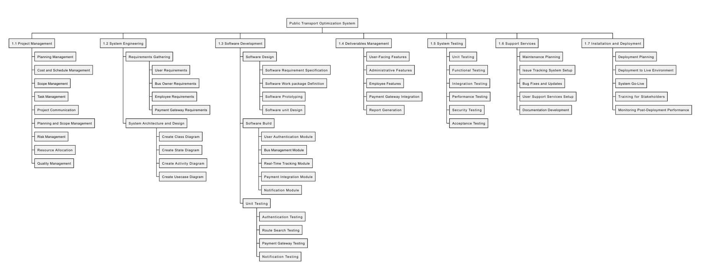**Work Breakdown Structure (WBS)**

**Project Estimation**

**DM** = 2.50 * (12.41)^0.38

= 5.63 ~ 6

Required number of people = **ST**

=PM / DM

=12.41/6

=2.06 ~ 3

**Project Name:** Public Transport Optimization

**Project Type:** Organic

Where,

P = 1.05

T=0.38

Coefficient = 2.4

SLOC=4780

Now,

**PM** = Coefficient <Effort Factor> * (SLOC/1000) ^ P

=2.4 (4780/1000)^1.05

= 12.41

**Timelinne Chart -1**



**Timeline Chart -2**

**EVA Exercise:**

|  |  |  |
| --- | --- | --- |
| Task | Planned Effort | Actual Effort |
| 1 | 10.0 | 8.5 |
| 2 | 6.0 | 7.0 |
| 3 | 3.0 | 4.0 |
| 4 | 2.0 | 3.0 |
| 5 | 2.0 | 1.0 |
| 6  BCWP = 37 | 2.0 | 2.0 |
| 7 | 3.0 | 3.5 |
| 8 | 3.0 | 3.0  ACWP = 38 |
| 9 | 3.0  BCWS = 49.0 | 2.5 |
| 10 | 3.0 | 3.5 |
| 11 | 2.0 | -- |
| 12 | 3.0 | -- |
| 13 | 2.0 | -- |
| 14 | 3.0 | -- |
| 15 | 2.0 | -- |
| Total Task = 64; Effort estimation = 273 Person Days | | |

* BAC = PM * 22 = 12.41 * 22 = 273
* SPI = BCWP / BCWS = 37 / 49 = 0.755
* SP = BCWP - BCWS = 37 - 49 = -12 Person-day
* CPI = BCWP / ACWP = 37 / 38 = 0.974
* CV = BCWP - ACWP = 37 - 38 = -1 Person-day

% schedule for completion = BCWS / BAC = 49 / 273 = 17.95%

[ % of work schedule to be done at this time ]

Complete = BCWP / BAC = 37 / 273 = 13.55%

[ % of work completed at this time]

|  |  |  |  |  |
| --- | --- | --- | --- | --- |
| Risk | Category | Probability | Impact | RRM |
| Size estimate may be significantly Low | PS | 60% | 2 |  |
| Larger number of users than planned | PS | 30% | 3 |  |
| Less reuse than planned | PS | 70% | 2 |  |
| Delivery deadline will be tightened | BU | 50% | 2 |  |
| Funding will be lost | CU | 40 | 1 |  |
| Customer will change requirements | PS | 80% | 2 |  |
| Technology Will not meet expectations | TE | 30% | 1 |  |
| Lack Of training on tools | DE | 80% | 3 |  |
| Staff inexperienced | ST | 30% | 2 |  |
| Staff turnover will be high | ST | 60% | 2 |  |
| Delayed development of core features like ticket validation or live tracking | PS | 40% | 2 |  |
| Inaccurate real-time updates due to GPS or network issues. | BU | 50% | 2 |  |
| Incorrect or incomplete financial reporting. | BU | 30% | 1 |  |
| |  | | --- | | Employees misuse their access to passenger information. | | |  | | --- | | BU | | 30% | 2 |  |
| Lack of training for employees to operate the system effectively. | PS | 40% | 3 |  |

Risk Table

|  |  |
| --- | --- |
| **Risks**  Risk Reduction Techniques | **Risk reduction techniques** |
| Size estimate may be significantly low | Adjust project scope or budget as needed; communicate change |
| Larger number of users than planned | Monitor user base closely; allocate additional resources if necessary |
| Less reuse than planned | Encourage modular design and code reuse; review during design phases |
| Delivery deadline will be tightened | Break project into smaller milestones to manage timelines effectively |
| Funding will be lost | Secure alternative funding sources or adjust project priorities |
| Customer will change requirements | Establish clear communication channels; document all changes |
| Technology will not meet expectations | Conduct proof of concept and prototype before full implementation |
| Lack of training on tools | Provide comprehensive training and support to all staff |
| Staff inexperienced | Provide mentoring and on-the-job training |
| Staff turnover will be high | Improve retention programs, ensure knowledge transfer documentation |
| Delayed development of core features like ticket validation or live tracking | Allocate buffer time in the schedule, prioritize critical features, and perform frequent progress reviews. |
| Inaccurate real-time updates due to GPS or network issues. | Implement redundancy by integrating multiple data sources or notifying users when updates are delayed. |
| Incorrect or incomplete financial reporting. | Perform thorough testing of financial reporting modules and integrate automated audits. |
| Employees misuse their access to passenger information. | Implement strict access control and audit logs to monitor employee actions. |
| Lack of training for employees to operate the system effectively. | Provide comprehensive training sessions and create detailed user manuals for employees. |

## Rubric for Project Assessment (CO3)

|  |  |  |  |  |  |
| --- | --- | --- | --- | --- | --- |
| Criteria | Marks distribution (Max 3X5= 15) | | | | Acquired  Marks |
| **Inadequate (1-2)** | **Satisfactory (3)** | **Good (4)** | **Excellent (5)** |
| Selection of Software Engineering Models | Does not articulate a position or argument of choosing appropriate model. Does not present any evidence to support the arguments for the choice of the model | Articulates a position or argument for choosing models that is unfocused or ambiguous. Presents incomplete/vague evidence to support argument for model choice | Articulates a position or argument of choosing models that is limited in scope. Does not present enough evidence to support the argument for the choice of the model | Clearly articulates a position or argument for the choosing software engineering models. Presents sufficient amount of evidence to support argument for the model selection |  |
| Role identification and Responsibility Allocation | The project has poor project management plans for identifying roles and assigning the responsibilities | Identify few roles in the project management where some of the roles are left alone with any project responsibilities | Identify most of the roles in the project management and assign their responsibilities | Well planned project with proper role identification and responsibility allocation in the project management activities |  |
| Impact identification |  |  |  |  |  |
| Formatting and Submission | Project report is not complete and Several errors in spelling and grammar. Present a Confusing organization of concepts, supporting  arguments, and  real-life example.  Sentences rambling, and details are repeated. | Some errors in spelling and grammar. Some problems  of organizing the answer in a logical order of defining,  elaborating, and providing real-life examples. | Few errors in spelling and grammar. Presents most of the details in a logical flow of  organization in  definition,  details, and  example. | Project report is complete and No errors in spelling and grammar. Consistently  presents a logical  and effective  organization of definition,  details, and real-life example of  the topic. |  |
| Acquired marks: | | | | |  |
| CO Pass / Fail: | | | | |  |

## Rubric for Project Assessment (CO4)

|  |  |  |  |  |  |
| --- | --- | --- | --- | --- | --- |
| Marking Criteria | Marks Distribution (Maximum 3X5=15) | | | | Acquired Marks |
| **Inadequate (1-2)** | **Satisfactory (3)** | **Good (4)** | **Excellent (5)** |
|  |  |  |  |  |  |
| Project Planning | No background information regarding the project is  given; project goals and benefits are  missing. | Insufficient background information is given; project goals and benefits are  poorly stated | Sufficient background information is given; the purpose and goals of the project are explained. | Thorough and relevant background information  is given; project goals are clear and easy to identify. |  |
| Effort Estimation and Scheduling | Student vaguely discuss the impact of societal, health, safety, legal and cultural issues in their project | Student provided with partial relevance to the impact of societal, health, safety, legal and cultural issues in their project | Student fairly provided the analysis to the impact of societal, health, safety, legal and cultural issues in their project | Student comprehensively provided the analysis to the impact of societal, health, safety, legal and cultural issues in their project |  |
| Risk Management | Ambiguous representative example. | Partially identify / indicate towards real-life example. | Real-life example is fairly connected towards the definition. | Comprehensively defend with real life example. |  |
| Acquired Marks: | | | | |  |
| CO Pass / Fail: | | | | |  |